**Build your own Bug Hotel**

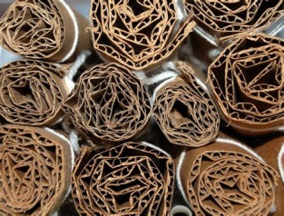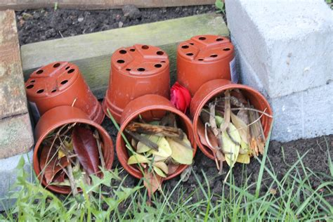

**Rolled up card or paper**

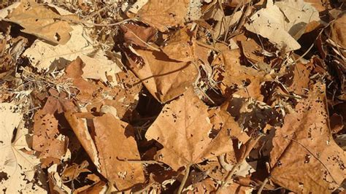**Dry leaves**

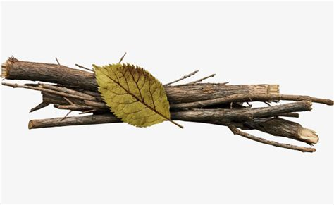**Dead wood**

**Loose bark**

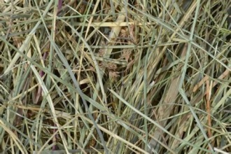**Hay/ straw** 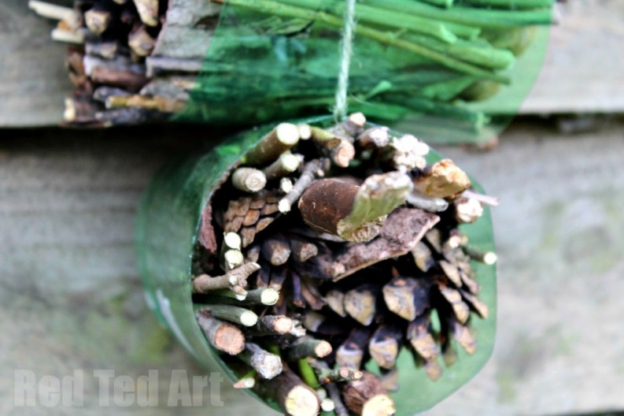

**Holes for solitary bees**

**Dead wood**

Dead wood is essential for the larvae of wood-boring beetles, such as the stag

beetle. It also supports many fungi, which help break down the woody material.

Crevices under the bark hold centipedes and woodlice.

**Holes for solitary bees**

Hollow stems, such as old bamboo canes, or holes drilled into blocks of wood, make

good nest sites for solitary bees. Holes of different diameters cater for different

**How to build a bug hotel**

species (6 to 8 mm holes are usually best, and just the depth of the drill bit). You can

place canes or hollow plant stems in a length of plastic drainpipe or traditional clay

drain pipe if you can find some.

**Straw and hay**

This provides many opportunities for invertebrates to burrow in and find safe

hibernation sites. Two small clay plant pots filled with straw attract solitary bumble

bees (you are not going to get a swarm of bees by doing this). Make sure the

drainage holes in the pots are clear.

**Dry leaves**

More homes for a variety of invertebrates; this mimics the litter on the forest floor.

**Loose bark**

Beetles, centipedes, spiders and woodlice all like decaying wood and bark.

**Hedgehog house**

Hedgehogs need a secure place to build their nests in; a wooden box under a pile of

sticks and debris in a sheltered corner is ideal. Add dry leaves inside as bedding.

**Toad hole**

Although frogs and toads need a pond to breed in, they can spend most of the year

out of water. Stone and tiles provide the cool damp conditions they need. The centre

of the mansion will provide a frost-free place during the winter.

**Crevices**

Many garden invertebrates need a safe place to hibernate in through the winter, and

cracks and crevices in the hotel are ideal.

**Lacewing homes**

Lacewings and their larvae consume large numbers of aphids, as well as other

garden pests. You can make a home for them by rolling up a piece of corrugated

cardboard and putting it in a waterproof cylinder, such as an old lemonade bottle.

**Ladybirds**

Ladybirds and their larvae are champion aphid munchers. The adults hibernate over

winter; they need dry sticks or leaves to hide in.

**Bumblebees**

Every spring, queen bumblebees search for a site to build a nest and found a new

colony. An upturned flowerpot in a warm sheltered place might be used.

**Nectar-producing plants**

Why not plant some nectar-rich flowers around your habitat. These provide essential

food for butterflies, bees and many other flying insects.