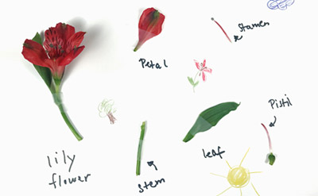
Dissect A Flower

What you will need:
- A flower a big flower is better as they are easier to identify the different part more easily such as a tulip, daffodil or lilly.
- Paper plate, card, paper
- knife or scissors
Lay your flower out over a paper plate, tray or sheet of cardboard. Can you identify the different parts?
Label areas of the different parts of a flower on your piece of cardboard or paper plate and place the dissected pieces with the correct label.
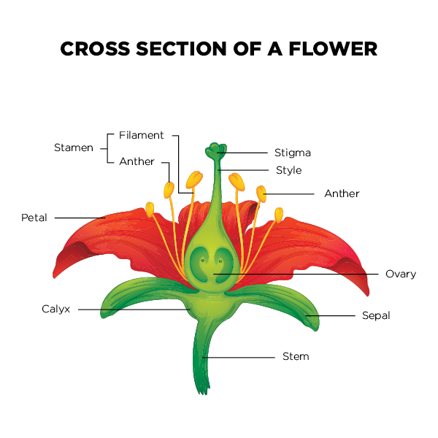
Try to find the following flower parts:
Root– carries water and nutrients from the soil to the plant and keeps it anchored in the ground.
Petal– often brightly coloured to attract insects
Leaf– uses energy from sunlight to photosynthesise creating oxygen and sugars for the plant to use for energy
Pollen– pollen is a fine powdery substance which contains the male reproductive cells. It is produced by the anthers of seed bearing plants.
Stem– a plant stem transports water and nutrients from the soil to the rest of the plant. The stem supports the leaves and flowers allowing them to be raised above the ground to be in the light.

FLOWER DISSECTION CHALLENGE
Can you find a stigma and anther and an ovule and ovary?
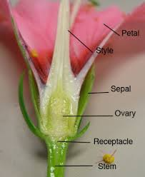
WHAT IS POLLINATION?
Pollination is when pollen from the anthers on another plant of the same type lands on the female parts of a plant. The female part of the plant , called the stigma, is sticky.
Pollen can be carried on the wind or by insects, once it has landed on the stigma of a plant it travels down a tube where it fertilises the ovules, which then become seeds.
WHAT IS FERTILISATION?
Fertilisation is when the males cells from the pollen connect with female cells from the ovules.

WHAT IS GERMINATION?
Germination is when a seed starts to sprout and grow, you could try to grow a bean in a jar to discover the conditions needed for a seed to germinate.
WHICH ARE THE BEST FLOWERS TO DISSECT?
Anything with large parts. Lilies are great but watch out for pollen stains. Tulips, Daffodils and Iris flowers also work well.

