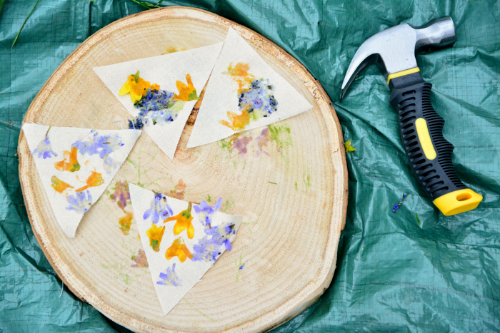
Hapa Zome (Leaf bashing)

WHAT YOU NEED
- Cloth or paper
- A hammer (we couldn’t find ours, so we used a rock!) You could also use a rolling pin
- Hard surface to hammer on
- Some flowers, leaves or other plants. Encouraging the kids collect the plants and colours they are drawn to.

WHAT YOU DO
1. Place the cloth or piece of paper on a hard surface (we used a log) Wooden chopping board works well.
2. Arrange the plant material on the fabric or paper.
3. Fold over the cloth or paper and have the kids start to hammer! If you want to protect the cloth more, you can put a piece of paper over it before pounding.
4. Open the cloth and remove the plant material.
5. Let dry.

To extend learning exploring creating symmetrical patterns. This can be linked to looking at symmetry in nature, such as butterfly.

