Nature Weaving
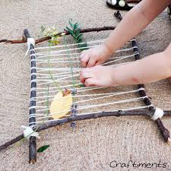
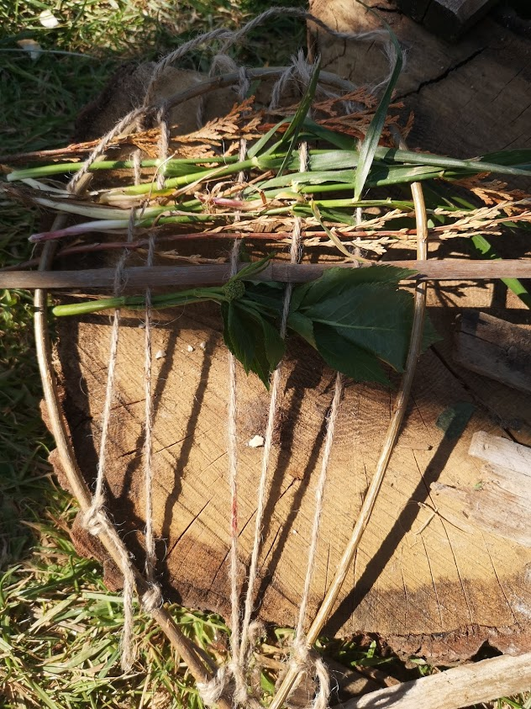
Have a go at making different types of nature looms, either with a stick frame or using cardboard ( this can be recycled from cereals or packing boxes)

You will need

- Sticks and anything you want to weave in it, long grass, flowers, leaves.
- String or wool.
- Cardboard
- Scissors

Step 1
Head out on a nature walk and collect some sticks, leaves, ferns and flowers. Take only what's abundant and only take a little.

Step 2
Using wool or string tie your sticks together in a square or triangle to make the frame of your loom. Then thread your wool or string across the frame from side to side. Ask a grown-up if you need help.

Step 3
Add your nature treasures into your loom. Weave them up and over, down and under your wool. Be creative! Have patience— with patience you'll become a better weaver.
Remember there is no right or wrong way to make a nature craft, so have fun!

