Outdoor learning Experiences
Find out all about what's in your soil.
Soil experiment
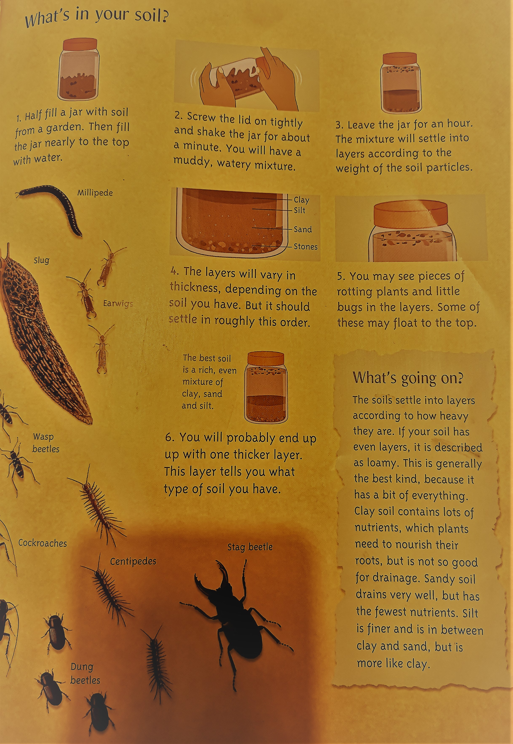

Watch this clip to help find out what type of soil you have.

https://www.youtube.com/watch?v=if29mjcd5bc

Bug Watch

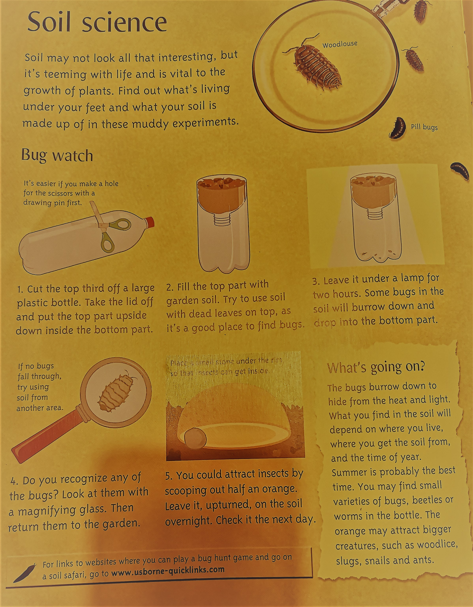
Can you keep a record of all the bugs you find?
What can you find out about them?
What do they eat?
How do they move?
https://www.woodlandtrust.org.uk/blog/2019/04/minibeast-hunt/

I have attached lots of different template for you to use or make your own.

Parts of an insect
Can you label the different parts of an insect or bug ?
KS2 can you do this independently? Can you identify any of these parts on a real bug or insect?

KS1 with support can you match the labels to the correct parts?

KS1 and Reception can you draw your bugs and insects you find? Can you label any parts of them?

