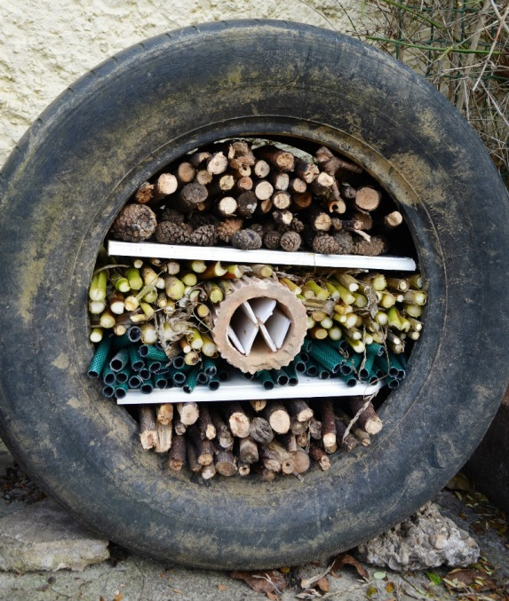

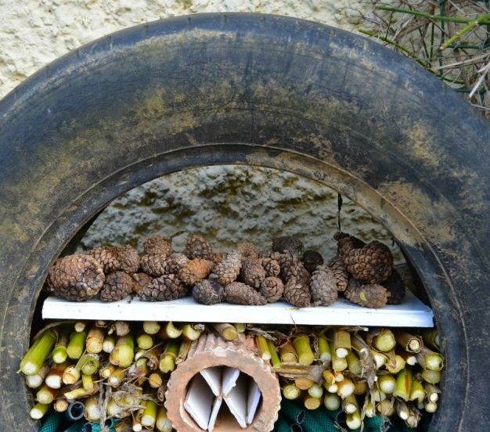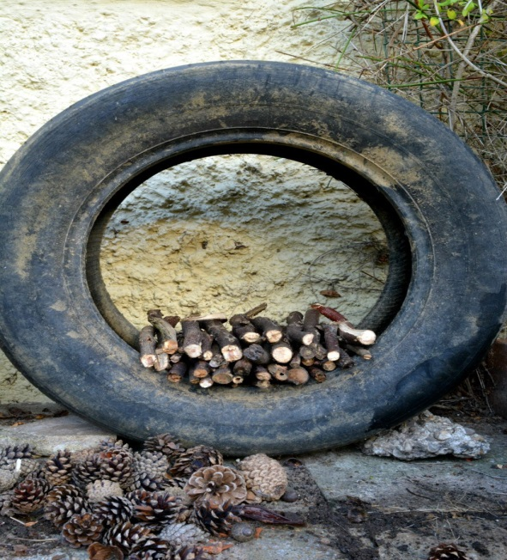

**Make a Bug Hotel**

**Places the different materials**

**you find in layers.**

**What materials do you think the bugs would like?**