Elder Beads

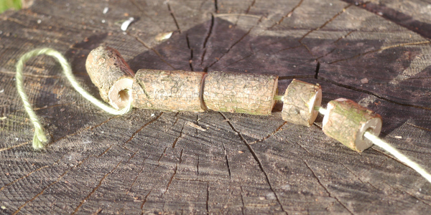
This is a firm favourite in our forest school sessions see the instructions on elderflower cordial on how to identify elder.
You will need:
- secateurs or loppers or a junior hack saw
- straight pieces of elder (ideally avoid points where leaves and branches sprout from the main part as the pith diameter can be smaller)
- tent peg or similar
- string/wool

Environmental considerations Consider the environmental impact of preparing be considerate when foraging .
Health & safety considerations think about your safety and where is a safe place to use tools(ask your adults fr help with tool use)
Step 1 – select your wood Cut your piece of elder; you will need a piece as thick as your thumb – about 1-2cm (ideally you want to work with the pith inside the diameter of a tent peg) and choose a straight piece. You will need secateurs or loppers to cut with.
Tip: if you plan to decorate the beads by carving the bark with a knife, it’s better to do it now, before you cut the beads to length. The bark is very easy to peel and can just be peeled off with hands or a good potato peeler.

Step 2 – cut the beads Cut small lengths of elder,
Measure and mark the elder first to make accurate lengths if you want to be precise. The elder can be cut in different ways: using bypass secateurs or loppers (if the scissor action squashes and breaks the elder then a saw would be better) a junior hacksaw is ideal for small fiddly jobs – the piece of wood needs to be held securely when sawing; a saw horse or a V-shape cut into a log can help with this.

Step 3 – remove the pith This is the fun bit! Poke out the pith using a tent peg of similar (blunt-ended). The pith should pop out very easily and it is quite addictive!

Step 4- decorate and assemble into a key chain, bracelet or necklace

