Elderflower cordial
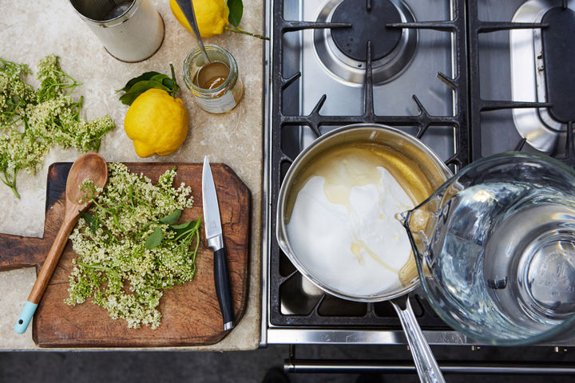
Ingredents
15 heads of elderflower ( remember to not take all the flowers from one tree but leave some for the wildlife)
500g caster sugar
4 tablespoons quality runny honey
2 unwaxed lemon
*for a twist try adding rubarb
See the link below to help identify elder trees and find elderflowers.
https://www.woodlandtrust.org.uk/blog/2019/05/how-to-identify-elder/
Instructions
1. Wash the elderflower well, picking off any bugs.
2. Place the sugar and honey in a large saucepan with 1 litre of water. Gently bring to the boil, until all the sugar has dissolved, then remove from the heat.
3. Finely grate in the lemon zest and add the elderflower upside down, making sure the flowers are completely submerged.
4. Squeeze in the juice from one of the lemons, then slice the other and add it to the pan, too. Pop the lid on and leave to one side to infuse for 24 hours.
5. When you’re ready to strain your cordial, line a fine sieve with muslin over a large bowl (if you don’t have muslin, you can use good quality kitchen towel) and pour through the cordial.

