Nature Crown

A perfect accessory for any cerebration I will be making some of these with my boys this week.

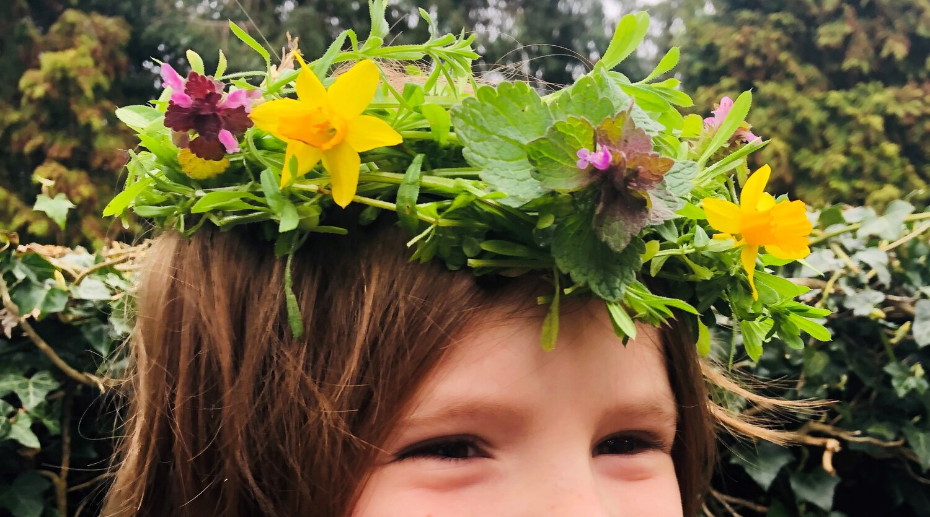
There are so many different ways to make nature crowns these are two of may favourite and very easy to do.

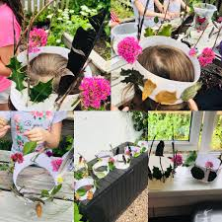

How to make a Sticky weed ( Cleavers) crown
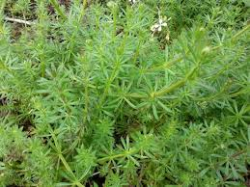

- Find some sticky weed, flowers and leaves
- Twist several pieces together then make it into a circle to fit around your head
- Add in your flowers and leaves to decorate it

Nature crown using paper

Collect things to decorate your crown, feathers, leaves, flowers and sticks.

- Cut paper or card into a strip to fit around your head
- Using double sided tape or glue attach your decorations
- leave to dry and then fit to your head

You could always attach ribbons to make it extra special .

