Leaves

Have a go at one of these leaf activities

You will need

- Different types of leaves
- paper
- crayons
- white candle wax or white crayon
- paint/ water colours
- felt tip pens
- sticky weed

Make a leaf crown or bracelet

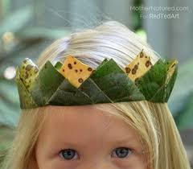
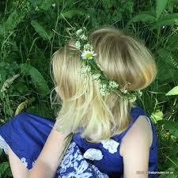

Leaf rubbing picture
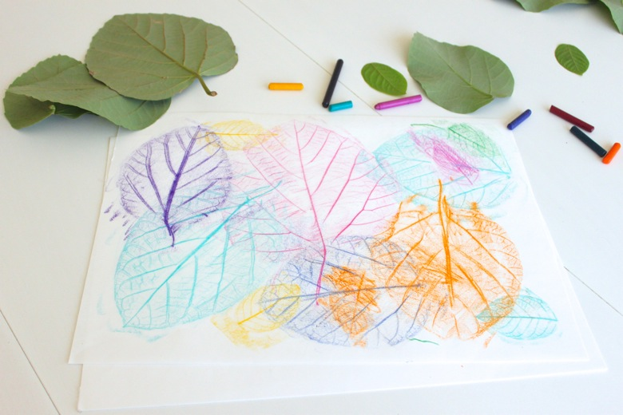
You can use crayons- place the leaf underneath the paper and then using the crayon length ways and rub it over the top and see what happens.
Leaf Prints
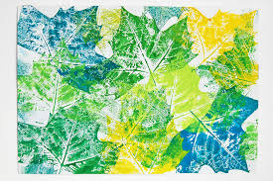

You can use paints or felt tips

- Using paint or felt tip cover one side of your leaf
- Then press onto the paper to make your print. If you are using felt tips be quick or else it will dry before you can make your print.

Magic leaf rubbing
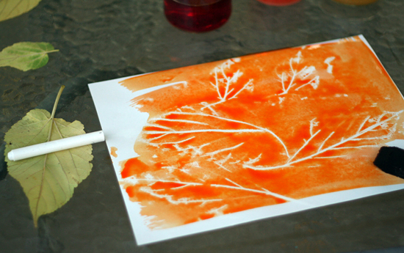

- Using a white wax of a candle or white crayon
- Do the same process as the leaf rubbing with crayons. But this time you wont see anything appear n your paper.
- Using water colours or watered down paint.
- Lightly paint over the top f your rubbing and watch the magic happen .
- Your pattern should appear.

