Paint Made From Berries and Nature
Step 1: Collect Items Needed to Make Paint From Nature
Berries, flowers, leaves, grass, mud or even skins from fruit or vegetables.
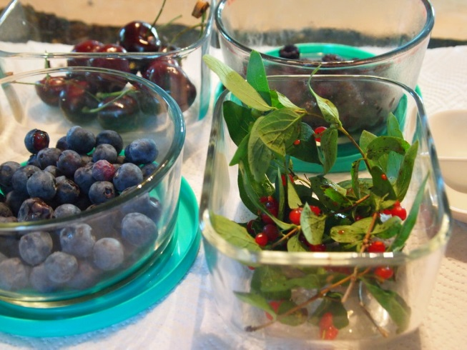
Step 2: Mashing & Collecting Juice
- If you have a pestal and motar use this to crush up your natural material.
- A fork and bowl will also work, if using leaves cut or tear them first.
- Once you have done this add a small amount of water to help extract the juice and colour from it. You can use either cold or boiling water. (if using boiling water ask an adult to help.
- Use a sieve to get all the juice out.
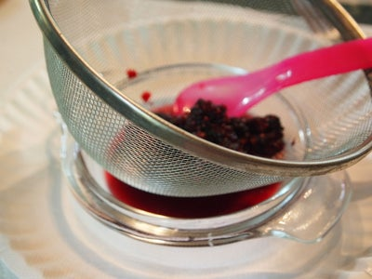

Step 3: Finishing Up the Paint-Making
Finally add some flour until it is a paint like consistency

