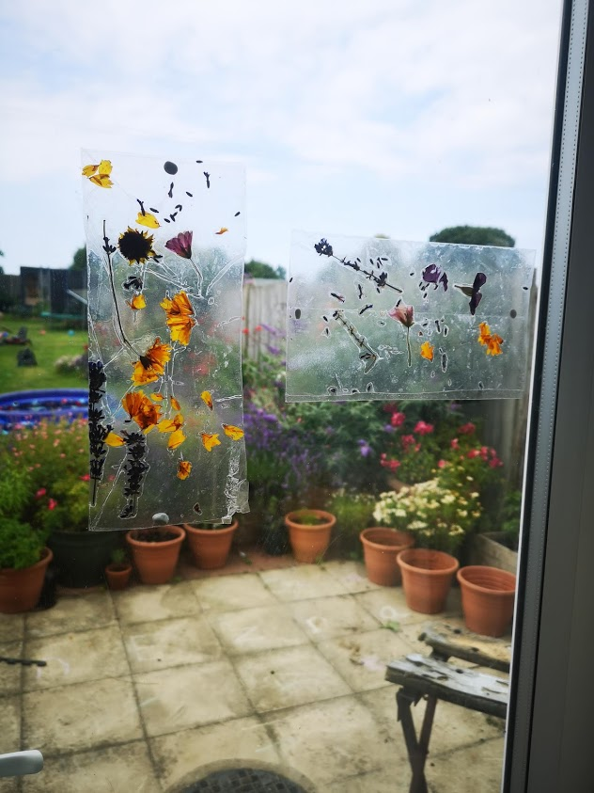
Sun catchers

Have a go at making some of your own sun catchers.
What you need:
Flowers and leaves
sticky back paper, or clear plastic from a container and cling film
You could use a paper plate, card or sticks as a frame

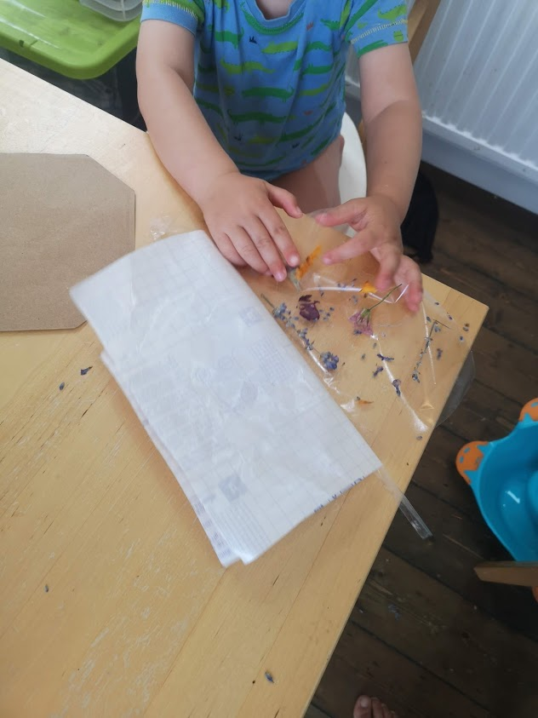
Press flowers in a flower-press or some heavy books. Place the flowers carefully on some paper or card and place in-between two heavy books. Leave for about a week and then check on them.

Using sticky back plastic peel off half of the backing and place the flowers on the sticky side. Then peel of the rest and fold in half to seal the flowers in between .

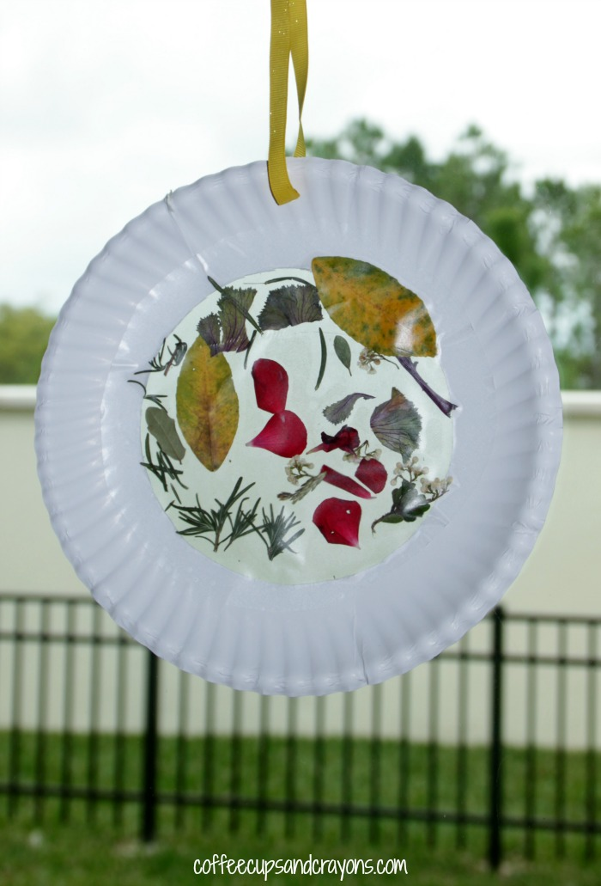
If using a frame cut two pieces of contact paper slightly bigger than the hole of the frame. Peel off the first piece and place on frame then add flowers
Then the other piece of contact paper over the top.

You can also use clear packaging and cling film, cut out a flat piece of the plastic container. Place the flowers on the shape and then place cling film over the top. The cling film with stick to the plastic.

My boys had lots of fun making theirs I hope you do too.

