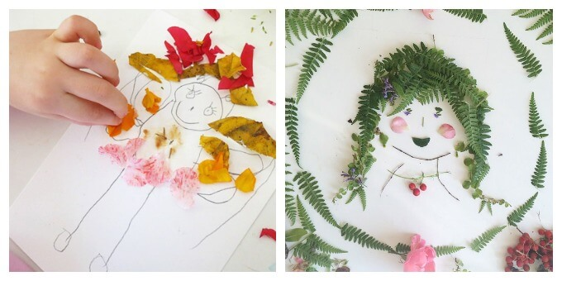
Nature Portraits

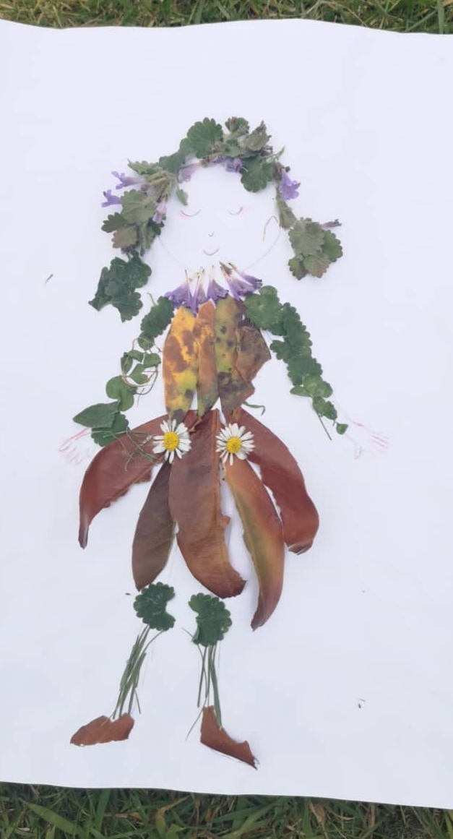
Have a go at making your own.
Can you do one of your whole family?

