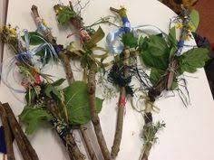
Journey Sticks

This is one we have done many times in forest school and never gets old.
You will need
some string or wool
a good size stick

What are journey sticks?

When the Aboriginal people of Australia went on journeys, they collected objects along the way, tying them to the stick in chronological order. When they returned home they would use their stick to retell their journey and stories from their travels.

The objects which they had collected on the way, acted as a reminder to things they had seen or done.

All you need is some string or wool and a stick, as you go on your walk collect things and tie them to your stick.

As an extra challenge can you use your journey stick to create a map of your adventure?

