Natural Paintbrushes
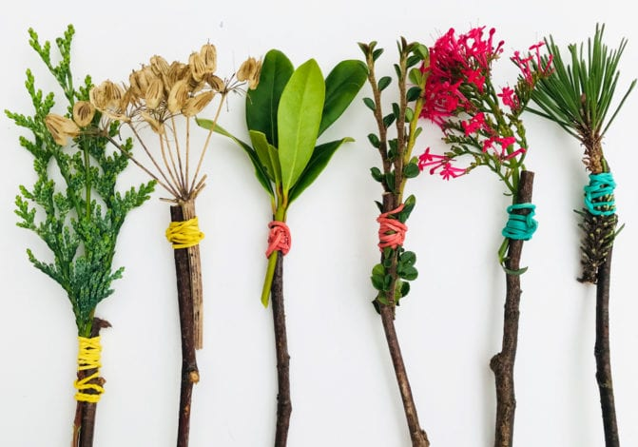

You will need

- a stick
- some string or elastic bands
- different types of leaves , grasses or flowers

Could you have a go at using them with mud or nature paint?

Do they create different patterns?

