Make a Cairns Stone Tower

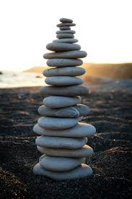
Cairns are man-made towers of natural stones, usually built as a landmark or a memorial, and making them is a great activity for kids.
All they need to do is gather a range of flat rocks and pebbles in different sizes, and then stack them in order, with the largest at the bottom and the smallest at the top.
Can they make changes to the structure of their cairn, such as using a foundation of lots of smaller stones, and see if it still stands?
This improves gross and fine motor skills, hand-eye coordination and concentration as they experiment with finding the stones’ balancing points to see how tall they can make their cairn.

